The ULTIMATE Grilled Chicken Sandwich
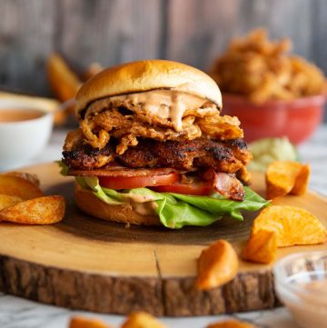
Ingredients
Chicken
4x 5oz / 150g boneless/skinless Chicken Thighs
1.5 tbsp Olive Oil
1 tbsp Lime Juice
1.5 tsp Smoked Paprika
1/2 tsp EACH: Salt, Onion Powder, Garlic Powder
1/4 tsp EACH: Cayenne Pepper, Black Pepper
Sandwich
4 Brioche Buns, toasted (see notes)
8 slices of Bacon, cooked to preference
4 tbsp mayo
4 Lettuce Leaves
3 Tomatoes, sliced (3 slices per sandwich)
Instructions
Pound Chicken: Lay a chicken thigh on your chopping board and cover with cling film (pinch around edges so no moisture escapes). Use a rolling pin or mallet to pound until even thickness, but not so thin it starts breaking apart. Repeat with remaining thighs.
Marinade: In a shallow bowl or the base of a zip lock bag, use a fork to whisk together smoked paprika, onion powder, garlic powder, salt, black pepper, cayenne pepper, lime juice and olive oil. Add in chicken thighs and combine until they're all completely covered with the marinade. Marinate for as long as you have time for (up to overnight). If you're in a rush just rest at room temp as you prep the other ingredients.
Grill Chicken: Bring chicken to room temp if marinated in the fridge, then add to a griddle pan over medium high heat. Fry until it begins to char (4-5mins), then flip and continue frying until charred on the second side and piping hot through the centre. Place to one side to rest.
Sandwich: Stack the sandwich in the following order - bottom bun, chipotle mayo, lettuce, tomato, bacon, chicken, crispy onions, top bun with more chipotle mayo spread on it. Enjoy!

